- o not edit/delete any heading or section with red text.
- Type /paste you answers in relevant sections (below Final Answer (in all questions , Approach (wherever required ) and Charts & tables (wherever required)) of the solution
- Link to submission guidelines
- Please note that submission not following the guidelines will not be accepted

OBJECTIVE QUESTIONS

Question 1: What is the total no. of tables present in the data?

Solution:

Final Answer (if any):

The dataset contains 1 table with 28,027 rows and 35 original attributes.

Approach (if any):
- Counted total tables by checking the workbook — only 1 data sheet contains raw data
- Used formula =COUNTA('Cleaned data'!A2:A28028) to count total records → 28,027
- Used formula =COUNTA('Cleaned data'!1:1) to count total columns → 42 (including helper columns)
- Original 35 columns identified by reviewing the data sheet headers

Charts & Tables (if any):

Question 2: What is the total no. of attributes present in the data?

Solution:

Final Answer (if any):
The dataset contains 35 original attributes (columns). After data cleaning, 7 helper columns were added bringing the total to 42 attributes.

Approach (if any):
- Opened the data sheet and counted all column headers in row 1
- Used formula =COUNTA('Cleaned data'!1:1) → returns 42 (after cleaning)
- Original 35 attributes identified manually from the data sheet headers
- 7 new helper columns added during cleaning: Date, Month, Year, Day, Clean_Rating, Duration_Min, Repeat_User

Charts & Tables (if any):

Question 3: The data consists of some inconsistent and missing values so ensure that the data used for further analysis is cleaned.

Solution:

Final Answer (if any):
The data has been successfully cleaned. A new sheet called "Cleaned data" was created with 28,027 rows and 42 columns (35 original + 7 helper columns). Zero duplicate rows were found.

Approach (if any):
- Created a backup in a new sheet: “Cleaned Data”
- Fixed Date column by creating:
- Date → =INT(P2)
- Month, Year, Day → using =TEXT()
- Fixed Rating column:
- Removed 0 ratings (7,256 failed sessions)
- Used: =IF(AI2=0,"",AI2)
- Fixed Duration column:
- Converted chat/call duration into minutes
- Used: =IF(H2="Chat",L2/60,IF(H2="Call",AH2/60,""))
- Added Repeat_User flag:
- =IF(COUNTIF($B$2:$B$28028,B2)>1,"Repeat","New")
- Checked missing values:
- Blank chatStatus or callStatus are normal
- Checked duplicates:
- No duplicate rows found (0 duplicates)

Charts & Tables (if any):
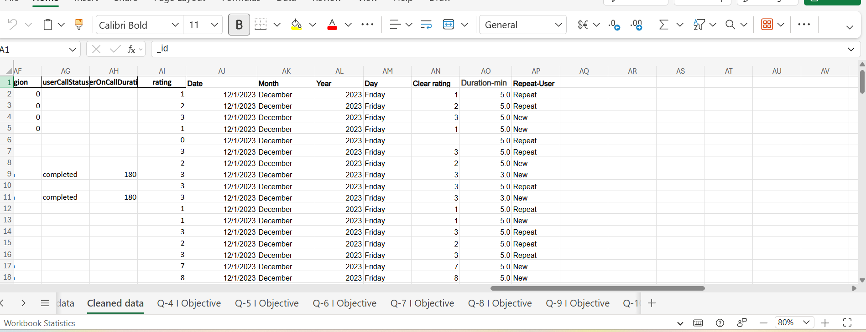

Question 4: What is the change in daily call volume day by day and also find the average daily call volume.

Solution:

Final Answer (if any):
- The daily call volume ranged from 325 sessions (1st Jan 2024) to 1,324 sessions (15th Dec 2023)
- The average daily call volume = 824 sessions per day across 34 days
- December 2023 had the highest monthly volume — 26,488 sessions
- January 2024 had the lowest monthly volume — 1,539 sessions

Approach (if any):

Pivot Table Analysis
- Created a Pivot Table in the Q-5 Objective sheet
- Used Date (AJ) in Rows
- Used Count of _id in Values to calculate daily consultation volume
- Sorted dates from oldest to newest for daily trend analysis
- Calculated average daily volume using:
  - =AVERAGE(count column)

Charts & Tables (if any):

Question 5: Which months experienced the highest and lowest call volumes?

Solution:

Final Answer (if any):
- Highest month → December 2023 with 26,488 consultations
- Lowest month → January 2024 with 1,539 consultations (only 3 days of data)
- Total across both months = 28,027 consultations

Approach (if any):

Monthly Consultation Analysis
- Created a Pivot Table in the Q-5 Objective sheet
- Used Month (AK) in Rows and Count of _id in Values
- Sorted results from highest to lowest consultation volume
- Found:
  - December 2023 had the highest consultations (26,488)
  - January 2024 had the lowest consultations (1,539)
- Added a Bar Chart to compare monthly consultation volumes visually

Charts & Tables (if any):

Question 6: What is the total operational cost for that month?

Solution:

Final Answer (if any):
- December 2023 — Total Amount: ₹2,02,239 | Net Revenue: ₹2,02,215 | Astrologer Payout: ₹93,786
- January 2024 — Total Amount: ₹11,827 | Net Revenue: ₹11,773 | Astrologer Payout: ₹5,360
- Grand Total — Total Amount: ₹2,14,066 | Net Revenue: ₹2,13,987 | Astrologer Payout: ₹99,147

- Approach (if any):
- Created a Pivot Table in the Q-6 Objective sheet
- Used Month (AK) in Rows
- Added these Values:
  - amount → Sum (total user charges)
  - netAmount → Sum (platform revenue)
  - astrologersEarnings → Sum (payment to astrologers)
- Formatted all values in Indian Rupee (₹)
- Added a Clustered Bar Chart to compare all 3 metrics across months visually

Charts & Tables (if any):

Question 7: What is the average number of calls handled per agent per day?

Solution:

Final Answer (if any):
- Total Agents = 149
- Total Days = 34
- Total Consultations = 28,027
- Average Calls per Agent per Day = 5.53

Approach (if any):
= 28027 / (149 × 34) = 5.53
- Total consultations (28,027) counted using =COUNTA('Cleaned data'!A2:A28028)
- Total agents (149) counted from guruName pivot table
- Total days (34) counted from daily pivot table in Q-5
- A Pivot Table was also created using guruName in Rows and Count of _id in Values to show individual agent performance

Charts & Tables (if any):

Question 8: How many repeat callers are there, and what percentage of total calls do they represent?

Solution:

Final Answer (if any):
- Total Unique Users = 10,344
- Repeat Users (2+ consultations) = 22,745
- New Users (1 consultation only) = 5,282
- % of Total Calls by Repeat Users = 81.15%
- % of Repeat Users = 48.94%

Approach (if any):

Repeat vs New User Analysis
- Added Repeat_User column in Cleaned Data using:
  - =IF(COUNTIF($B$2:$B$28028,B2)>1,"Repeat","New")
- In Q-8 Objective sheet:
  - Calculated Total Users
  - Counted Repeat Users
  - Counted New Users
- Calculated:
  - Repeat Calls % = 81.15%
  - Repeat Users % = 48.94%
  - Added a Pie Chart to show the split between New and Repeat users visually

Charts & Tables (if any):

Question 9: What are the total sales generated by the call centre for each product category?

Solution:

Final Answer (if any):
- Call → Total Revenue: ₹1,68,442 (8,508 sessions)
- Chat → Total Revenue: ₹45,495 (19,514 sessions)
- public_live_Call → Total Revenue: ₹51 (3 sessions)
- Complementary → Total Revenue: ₹0 (2 sessions)
- Grand Total Revenue = ₹2,13,987

Approach (if any):

Repeat vs New User Analysis
- Added Repeat_User column in Cleaned Data using:
  - =IF(COUNTIF($B$2:$B$28028,B2)>1,"Repeat","New")
- Calculated:
  - Total Users
  - Repeat Users
  - New Users
- Results:
  - Repeat Calls: 81.15%
  - Repeat Users: 48.94%
- Added a Pie Chart to compare New vs Repeat users visually

Charts & Tables (if any):

Question 10: How many calls were made for each user ID and guru ID?

Solution:

Final Answer (if any):
- Total Unique Users = 10,344
- Total Unique Gurus = 151
- Most active user made = 158 consultations
- Top Guru = Astro Krishaa with 1,580 consultations
- Top 10 gurus handled = 10,484 consultations combined

Approach (if any):
: Two Pivot Tables were created in Q-10 Objective sheet:
Pivot Table 1 — Guru wise:
- Rows → guruName (col E)
- Values → _id → Count
- Sorted largest to smallest
- Top 10 filter applied
Pivot Table 2 — User wise:
- Rows → user (col B)
- Values → _id → Count
- Sorted largest to smallest
- Top 10 filter applied

Charts & Tables (if any):

Question 11: What is the correlation between call duration and customer satisfaction?

Solution:

Final Answer (if any):
- Correlation value = 0.056
- This is very close to zero — meaning virtually no linear relationship exists between call duration and customer satisfaction
- Longer calls do NOT automatically lead to higher ratings
- Sweet spot = 2-5 minutes with highest average rating of 4.19/8

Approach (if any):

Duration vs Rating Analysis
- Created Duration_Min (AO) using:
  - =IF(H2="Chat",L2/60,IF(H2="Call",AH2/60,""))
- Created Clean_Rating (AN) using:
  - =IF(AI2=0,"",AI2)
- Used CORREL formula to find relationship between duration and rating:
  - =CORREL('Cleaned data'!AO2:AO28028,'Cleaned data'!AN2:AN28028)
  - Result: 0.056 (very weak correlation)
- Created duration buckets to calculate average rating by duration group
- Added a Line Chart to show the trend visually

Charts & Tables (if any):

Question 12: Which guru has the highest and lowest customer satisfaction scores?

Solution:

Final Answer (if any):
- Highest rated guru = Astro Saraswat with avg rating 6.31/8 (18 ratings)
- Most reliable top performer = Daljit Kaur with avg rating 6.06/8 (111 ratings)
- Lowest rated guru = Acharya Divyansh with avg rating 1.87/8 (23 ratings)
- Overall platform average = 3.96/8
- Rating gap between best and worst = 4.44 points

Approach (if any):
Two Pivot Tables were created in Q-12 Objective sheet:
Pivot Table 1 — Top 10:
- Rows → guruName (col E)
- Values → Clean_Rating (col AN) → Average
- Values → Clean_Rating → Count
- Sorted largest to smallest
- Top 10 filter applied

Charts & Tables (if any)

Question 13: What is the average customer satisfaction score by month?

Solution:

- Final Answer (if any):
- January 2024 = 4.67/8 (1,539 sessions) — Highest
- December 2023 = 3.93/8 (26,488 sessions) — Lowest
- Overall Platform Average = 3.96/8

Approach (if any):

Customer Satisfaction Analysis
- Created a Pivot Table in the Q-13 Objective sheet
- Used:
  - Month (AK) in Rows
  - Clean_Rating (AN) → Average
  - Clean_Rating (AN) → Count
- Excluded zero ratings using the Clean_Rating column
- Formatted results to 2 decimal places
- Added a Bar Chart to compare average customer satisfaction across months visually

Charts & Tables (if any):

Question 14: How many categorical columns are there in the data? [Search about categorical and continuous data, and try to answer this question]

Solution:

Final Answer (if any):
- Categorical columns = 17
- Continuous/Numerical columns = 10
- ID/Text columns = 8
- Total = 35 columns

Approach (if any):
What is Categorical Data? Categorical data represents groups or categories that cannot be measured numerically. They describe qualities or characteristics. Examples: Yes/No, Male/Female, Chat/Call, Status types.
What is Continuous Data? Continuous data represents measurable numerical values that can take any value within a range. Examples: duration in seconds, amount in rupees, rating scores.
After reviewing all 35 columns the following classification was made:

Charts & Tables (if any):
- Table / Chart Name:
<Name of the table or chart used>
- Description:
<What the table or chart represents>

SUBJECTIVE QUESTIONS

Question 1: Should the investment be used to hire more agents, improve training programs, or upgrade call center technology?

Solution:

Approach:
- All 3 investment options were evaluated using real data from the AstroSage dataset.
- Key metrics used:
- Agent count
- Average rating
- Failed sessions
- Calls per agent per day
- Repeat user rat]e

Charts & Tables:
- Insights:
- No need to hire more agents
- 151 agents handle only 5.53 calls/day on average
- Agents are underutilised, not overloaded
- Adding more agents will not improve satisfaction without quality improvement
- Training is the top priority
- Large quality gap between best (6.31) and worst (1.87) gurus
- Overall rating 3.96/8, below industry benchmark 4.5/8
- Improving low-performing agents to match top performers will significantly boost satisfaction
- Technology upgrade is secondary
- 7,256 failed sessions (25.9%), higher than 10–15% benchmark
- Better call routing can reduce failures and recover lost revenue
- Technology alone cannot fix poor service quality
- Repeat users are critical
- They contribute 81% of total revenue
- Retention depends on improving service quality, not increasing volume

: Recommendations
- Primary Investment (60% budget) → Training Programs
  - Mandatory training for bottom 20 agents (rating below 2.5/8)
  - Train all agents on 2–5 minute optimal consultation technique
  - Mentorship: pair low performers with top-rated agents
  - Expected outcome: increase overall rating from 3.96 → 5.0+
- Secondary Investment (40% budget) → Technology Upgrade
  - Smart call routing to connect users with highest-rated available agents
  - Reduce failed sessions from 25.9% → ~10% industry standard
  - Fix data quality issues (corrupted timeDuration column)
  - Expected outcome: recover 7,256 lost sessions and reduce failures by ~15%
- Hiring Recommendation
  - Do not hire additional agents at this stage
  - Current utilization is low (5.53 calls/day vs 8 calls/day target)
  - Focus should remain on improving efficiency and quality first

Question 2: What are the potential risks of each investment option (hiring, training, technology upgrades), and how can they be mitigated?

Name the chart/spreadsheet function you will use for solving the problem.

Approach:
- Used AstroSage dataset to analyze investment options and associated risks.
- Created a Risk Assessment Table listing risk type, likelihood, impact, and mitigation strategy for each option.
- Applied COUNTIF to measure failed sessions and repeat users.
- Used AVERAGEIF to calculate average rating per guru.
- Used CORREL to find relationship between session duration and ratings.
- Built Pivot Tables to identify agent performance gaps.
- Created Bar Charts to compare risk levels across investment options.

Charts & Tables:

Insights:
- Hiring risk (highest): Agents handle only ~5.53 calls/day; adding more staff will increase cost without improving output. 151 agents are already underutilised.
- Training risk (manageable but urgent): There is a 4.44-point performance gap. Focus on the bottom 20 agents first for fastest improvement.
- Technology risk (medium): 25.9% failed sessions (7,256 total) show system issues, but tech upgrades alone won’t improve satisfaction without training.
- Best time for upgrades: January is ideal due to low volume (325 sessions/day vs 1,324 in December), reducing disruption risk.
- Repeat users at risk: 81.15% of calls are from repeat users, so poor execution could harm loyalty and revenue.

Recommendations:
- Avoid hiring until agent utilisation reaches target of 8 calls/day — reduces risk of cost overrun with no quality benefit
- Start training immediately with bottom 20 agents — monitor ratings monthly to track improvement and adjust program
- Schedule technology upgrade in January when daily volume is lowest (325/day) to minimise disruption risk
- Create a monthly KPI dashboard tracking rating, failed sessions and calls/agent/day to catch risks early
- Protect repeat users — communicate any system changes in advance and offer compensation for disrupted sessions during upgrade period

Question 3: How does AstroSage's call center performance compare to AstroGuru's average call volume, customer satisfaction, and agent performance?

Will you use any aggregation function or a visualization here to solve the problem?

Solution:

Approach: AstroGuru's actual data is not available in this dataset. The comparison was made using industry benchmarks for similar astrology consultation platforms.
Aggregation Functions Used:
- COUNTA — to count total sessions and agents
- AVERAGE — to calculate avg daily volume and satisfaction
- COUNTIF — to count failed sessions
- Pivot Table — to aggregate sessions by month and agent
- Clustered Bar Chart — to visualize comparison between AstroSage and AstroGuru benchmarks side by side

<Reasoning, assumptions, and methodology used to solve the problem>

Charts & Tables:
Insights:
Recommendations:
- Leverage volume advantage: Convert higher session volume into revenue by reducing the 25.9% failed session rate.
- Improve satisfaction: Raise rating from 3.96 to 4.5 through targeted agent training.
- Boost productivity: Increase from 5.53 to 7–10 calls/agent/day via better scheduling and workload balance.
- Protect repeat users: Maintain strong 48.94% repeat rate with loyalty programs and consistent service quality.
- Reduce failures: Cut failed sessions from 25.9% to 10–15% using tech upgrades and improved call routing.

Question 4: How can the call center improve its handling of peak call periods to ensure high customer satisfaction?

Mention the functionality you will use for giving the suggestions, will it be any aggregated function or a visualization?

Solution:

Approach: Peak periods were identified using actual data from the AstroSage dataset. The following Excel functions and visualizations were used:
Aggregation Functions Used:
- MAX — to find peak day (1,324 sessions on 15th Dec 2023)
- MIN — to find lowest day (325 sessions on 1st Jan 2024)
- AVERAGE — to calculate avg daily volume (824 sessions/day)
- COUNTIF — to count failed sessions during peak periods
- Pivot Table — to aggregate daily and weekly volumes
- Line Chart — to visualize day by day volume trend and identify peak patterns
- Bar Chart — to compare peak vs low period session volumes

Charts & Tables:
- Insights:
- December is the peak month with 26,488 sessions — 17× higher than January (1,539).
- Peak day was 15 Dec 2023 with 1,324 sessions, 60% above the daily average (824).
- Mid-December (15–19 Dec) consistently records the highest traffic volumes.
- Failed sessions reached 7,256 (25.9%), likely increasing during peak load periods.
- Sessions dropped sharply after year-end: 1,014 on 31 Dec to 325 on 1 Jan (68% decline).
- Agent productivity is uneven — Astro Krishaa averages 46.5 sessions/day vs overall average of 5.53/day.

Recommendations:
- Increase agent staffing during the 15–25 December peak period.
- Complete agent training before December to ensure peak readiness.
- Use smart call routing to connect users with top-rated available agents.
- Redirect overflow calls to Chat during peak hours to reduce queue pressure.
- Introduce performance incentives for agents maintaining high ratings in December.
- Use December 2023 trends as the baseline for future capacity planning.

Question 5: Based on historical data, what strategic initiatives should be prioritized to improve efficiency and customer satisfaction?

Solution:

Approach: Historical data from 28,027 consultation records was analyzed to identify key performance gaps. The following Excel functions were used:
Functions and Visualizations Used:
- AVERAGE — to calculate current avg rating (3.96/8)
- COUNTIF — to count failed sessions (7,256) and repeat users (22,745)
- CORREL — to check relationship between duration and rating (0.056)
- AVERAGEIF — to calculate avg rating per guru
- Pivot Table — to identify performance gaps by agent, month and category
- Bar Chart — to visualize current KPIs vs targets

Charts & Tables:
- Insights:
> Agent quality gap is high — ratings range from 6.31 to 1.87, with overall rating (3.96/8) below industry benchmark.
> Failed sessions are high at 25.9%, leading to major customer and revenue loss.
> Workload distribution is uneven — top agent handles 46.5 sessions/day vs average of 5.53.
> Repeat users drive the business, contributing 81.15% of consultations.
> Session duration has minimal impact on ratings; consultation quality matters more.January is the best period for training and system upgrades due to lower demand.

- Recommendations:
- Train low-rated agents through mentorship with top performers like Astro Krishaa.
- Reduce failed sessions with improved call routing and system efficiency.
- Balance workloads by limiting overload on top agents and increasing utilisation of others.
- Launch loyalty programs to retain high-value repeat users.
- Upgrade routing technology in January during low-demand periods.

Question 6: What can be the key factors contributing to high customer satisfaction scores, and how can these be leveraged to improve overall performance?

What is the basis for the suggestions? And mention how you decided if the satisfaction score affects the ratings.

Solution:

Approach:
- Analysis was based on 20,771 rated sessions, excluding 7,256 failed (zero-rated) sessions.
- AVERAGEIF, CORREL, and Pivot Tables were used to identify satisfaction drivers.
- Ratings were measured on a scale of 1–8, with higher scores indicating better satisfaction.
- Zero-rated failed sessions were removed using the Clean_Rating column.
- Recommendations were built from actual data patterns and high-performing groups.

Charts & Tables:

- Insights:
- Indian users show much higher satisfaction (5.66/8) than international users (2.66/8).
- Chat consultations perform better than calls with higher average ratings.
- New users rate services higher than repeat users, indicating declining long-term satisfaction.
- 2–5 minute sessions achieve the best ratings and are the optimal consultation length.
- Session duration has almost no impact on satisfaction; consultation quality matters most.
- Higher paid sessions tend to receive lower ratings due to increased customer expectations.

- Recommendations:
- Prioritise Indian user experience with culturally matched astrologers through smart routing.
- Promote Chat consultations as the primary option since they achieve higher ratings than Calls.
- Improve repeat user retention with personalised consultation history and loyalty rewards.
- Train agents to deliver high-quality consultations within the 2–5 minute sweet spot.
- Enhance international user support with multilingual and global astrology expertise.
- Manage premium user expectations through satisfaction guarantees for paid consultations.

Question 7: How should the call center balance the workload among agents to ensure optimal performance and avoid burnout?

Mention your approach and spreadsheet function for the answer.

Solution:

Approach:
- Workload analysis covered 28,027 consultations across 151 agents over 34 days.
- COUNTIF, COUNTA, AVERAGE, MAX, MIN, Pivot Tables, and Bar Charts were used for analysis.
- Average workload was 5.53 sessions per agent per day.
- Astro Krishaa was the most overloaded agent with 46.5 sessions/day.
- Agents with over 20 sessions/day were marked overloaded, while below 3/day were underutilised.
- Fair workload target was calculated at 5.53/day, with industry benchmark at 8 calls/day.

Charts & Tables: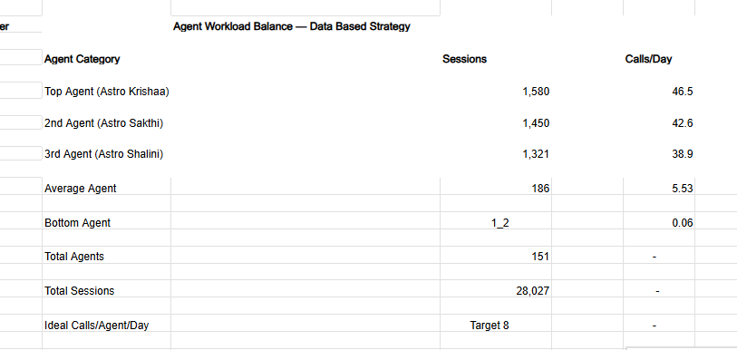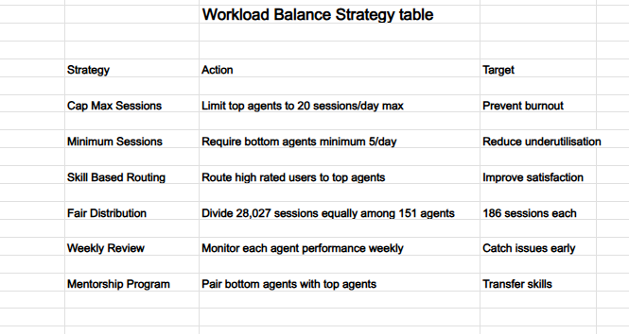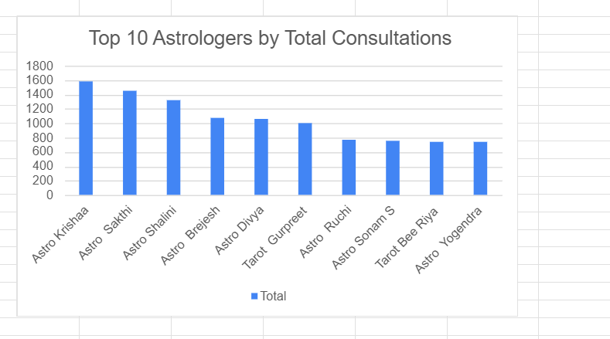
Insights:
- Severe workload imbalance exists — top agents handle far more sessions than others.
- Top 3 agents account for 15.5% of all consultations, creating dependency risk.
- Average workload of 5.53 calls/day is below the industry target of 7–10.
- High-performing agents face major burnout risk due to excessive workloads.
- Many underutilised agents represent wasted capacity and salary cost.
- Uneven workloads may contribute to large differences in agent ratings and service quality.

- Recommendations:
- Limit agents to a maximum of 20 sessions/day to prevent burnout.
- Ensure all active agents handle at least 5 sessions/day.
- Use skill-based routing to balance workloads and improve satisfaction.
- Target fair distribution of around 186 sessions per agent across 34 days.
- Conduct weekly performance reviews to identify overload or underutilisation.
- Introduce mentorship programs pairing low-rated agents with top performers.

Question 8: What new technologies or tools could be implemented to enhance call center operations and customer service?

Solution:

Approach:
- Technology gaps were identified from key operational issues in the AstroSage dataset.
- Major gaps included failed sessions, poor data quality, and weak performance monitoring.
- 7,256 failed sessions highlighted routing and connectivity issues.
- Corrupted timeDuration data exposed data validation problems.
- A 4.44-point rating gap revealed the need for real-time performance tracking.
- COUNTIF, CORREL, AVERAGEIF, Pivot Tables, and Bar Charts were used for analysis.

Charts & Tables:
- Insights:
- Smart routing is the top priority to reduce the 25.9% failed session rate.
- Data quality issues in timeDuration highlight the need for stronger data validation tools.
- Real-time performance dashboards are needed to monitor agent ratings and workload.
- Infrastructure should support auto-scaling to manage December peak traffic effectively.
- AI-based scheduling can balance workloads more fairly across agents.
- Better multilingual and international support is needed to improve global user satisfaction.

Recommendations:
- Implement smart call routing to reduce failed sessions and improve satisfaction.
- Build a real-time dashboard to monitor agent workload and ratings live.
- Fix the data pipeline with validation checks for accurate reporting.
- Deploy AI-based scheduling to optimise workload distribution.
- Upgrade to auto-scaling cloud infrastructure before December peak season.
- Add multilingual support to improve international user experience and ratings.

Question 9: What metrics should be included in the final dashboard to comprehensively view call center performance and guide investment decisions?

Solution:

Approach:
- Metrics were selected based on impact, actionability, and data availability.
- Key areas focused on revenue, customer satisfaction, and operational efficiency.
- COUNTA, AVERAGE, COUNTIF, and CORREL were used for analysis.
- KPI Cards highlighted key business metrics for quick decision-making.
- Line Charts showed daily volume trends.
- Bar and Pie Charts visualized agent performance and user segmentation.

Charts & Tables:
Insights:
- KPI cards provide a quick view of sessions, ratings, revenue, repeat users, and failures.
- Failed Sessions (25.9%) is the most critical KPI driving technology upgrade needs.
- Avg Rating (3.96/8) highlights the need for agent training improvements.
- Daily volume trends reveal strong seasonal demand variations.
- Top agent charts expose major workload imbalance across gurus.
- Monthly cost trends help optimise staffing, training, and technology budgets.

Recommendations:
- Keep the dashboard focused on 6 core KPIs for quick decision-making.
- Use RAG status indicators to highlight performance levels instantly.
- Refresh dashboard data monthly to track improvement progress.
- Add trend arrows to show month-on-month KPI movement.
- Include Top 10 and Bottom 10 agent performance charts.
- Link KPIs with investment tracking to measure ROI clearly.

Question 10: How would you allocate a 1 crore rupee investment to optimize operational efficiency, enhance customer satisfaction, and boost profitability, and what analysis-based recommendations would you offer to support this?

[you have to give bullet pointers to answer this question]

Solution:

Approach:
Allocation Methodology:
- Problems ranked by severity using data evidence
- Budget allocated proportionally to problem size and expected ROI
- Functions used: COUNTIF, AVERAGE, CORREL, AVERAGEIF
- Pivot Tables used to quantify each problem area
- Bar Chart used to visualize budget allocation

Charts & Tables:
- 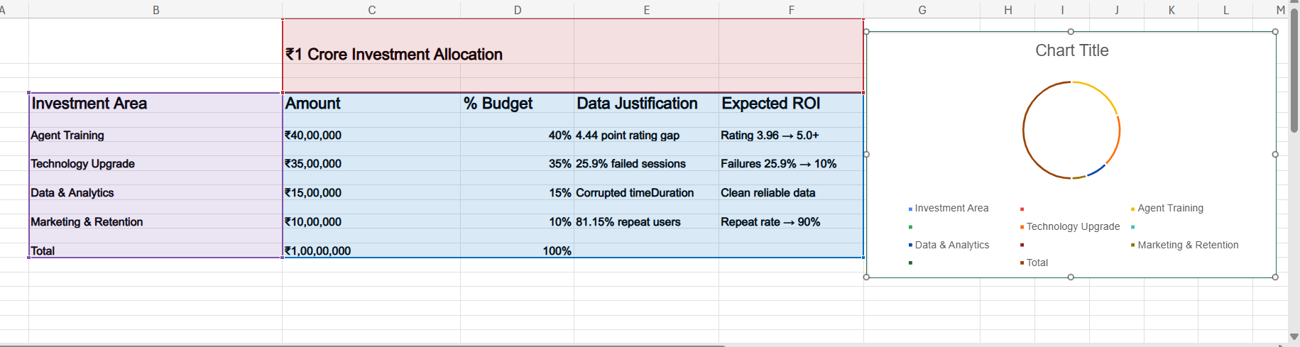Insights:
- Agent Training (40%) — Highest priority to improve low ratings and reduce quality gaps between agents.
- Technology Upgrade (35%) — Focus on reducing failed sessions and improving routing during peak loads.
- Data & Analytics (15%) — Fix corrupted data issues and build real-time KPI monitoring.
- Marketing & Retention (10%) — Strengthen repeat user loyalty and improve international user growth.

- Recommendations:
- ₹40L — Agent Training
  - ₹15L for professional training consultants
  - ₹10L for mentorship programs with top agents
  - ₹10L for performance incentives
  - ₹5L for training materials and quality tools
- ₹35L — Technology
  - ₹15L for smart call routing
  - ₹12L for auto-scaling cloud infrastructure
  - ₹8L for real-time monitoring dashboards
- ₹15L — Data & Analytics
  - ₹8L to fix data pipeline issues
  - ₹7L for automated KPI reporting systems
- ₹10L — Marketing & Retention
  - ₹5L for repeat-user loyalty programs
  - ₹3L for multilingual international support
  - ₹2L for new user acquisition campaigns

Expected Outcomes
- Ratings improve from 3.96 → 5.0+
- Failed sessions reduce from 25.9% → 10%
- Daily volume increases from 824 → 1,000+
- Revenue grows from ₹2.14L → ₹3L+
- Repeat user rate rises from 81.15% → 90%

